**An Intelligent Approach to Mitigate the Effects of Dynamic Movements in FMG technique for Upper Limb Prosthesis.**

Muhammad Bilal

Master of Science in Mechatronics Engineering

A thesis submitted in partial fulfillment of the requirements for

the degree of Master of Science (Mechatronics Engineering) at the

University of Engineering and Technology



Department of Mechatronics Engineering

University of Engineering and Technology,

Peshawar

2023

Plagiarism Undertaking

I take full responsibility of the project work conducted during the Master’s Project titled, An Intelligent Approach to Mitigate the Effects of Dynamic Movements in FMG technique for Upper Limb Prosthesis. I solemnly declare that the research work presented in the project is done solely by me with no significant help from any other person; however, small help wherever taken is duly acknowledged. I have also written the complete report by myself. Moreover, I have not presented this project (or substantially similar research work) or any part of the project previously to any other degree awarding institution within Pakistan or abroad.

I understand that the management of University of Engineering and technology has a zero-tolerance policy towards plagiarism. Therefore, I as an author of the above-mentioned project report, solemnly declare that no portion of my thesis has been plagiarized and any material used in the project from other sources is properly referenced. Moreover, the project does not contain any literal citing of more than 70 words (total) even by giving a reference unless I have the written permission of the publisher to do so. Furthermore, the work presented in the project is my own original work and I have positively cited the related work of the other researchers by clearly differentiating my work from their relevant work. I further understand that if I am found guilty of any form of plagiarism in my project work even after my graduation, the University reserves the right to revoke my MS degree. Moreover, the University will also have the right to publish my name on its website that keeps a record of the students who plagiarized in their thesis work.

Muhammad Bilal

Date: _____

Author’s Declaration

I Muhammad Bilal, hereby state that my MS project titled An Intelligent Approach to Mitigate the Effects of Dynamic Movements in FMG technique for Upper limb Prosthesis is my own work and it has not been previously submitted by me for taking partial or full credit for the award of any degree at this University or anywhere else in the world. If my statement is found to be incorrect, at any time even after my graduation, the University has the right to revoke my MS degree.

Date: ______

**Certificate of Approval**



*It is certified that the Master’s project work presented in this report, entitled* **An Intelligent Approach to Mitigate the Dynamic Effects in FMG technique for Upper limb Prosthesis** *was conducted by Muhammad BIlal under the supervision of*

*Dr* Izhar ul Haq

*No part of this project has been submitted anywhere else for any other degree*

*This project is submitted to the* MECHATRONICS ENGINEERING *in partial fulfillment of the requirements for the degree of Master of Science in* MECHATRONICS ENGINEERING

*At the*

*University of Engineering and Technology*

*Peshawar, PAKISTAN*

*MAY 2023*

Candidate Name: Signature: ______________

**Examination Committee:**

a) Examiner: _____________________ Signature: ______________

b) Examiner: _____________________ Signature: ______________

Abstract

This research paper aims to advance the clinical applicability of Force Myography (FMG) technology, particularly for the benefit of individuals with disabilities. FMG is employed to map muscle deformation resulting from gesture recognition, utilizing force-sensing resistors mounted on a flexible band wrapped around a person's area of effect to detect muscle stiffness. Even residual limbs with minimal muscle tissue can facilitate effective human-machine interfaces for appropriate actions using FMG.

Machine learning algorithms play a critical role in providing highly accurate results. Despite significant progress in precision over the past two decades, there remains a substantial gap between laboratory testing and clinical trials. This paper seeks to address this disparity by exploring methods for enhancing FMG performance outside of controlled laboratory environments, thereby improving its potential for real-world applications and positively impacting the lives of disabled individuals.

Keywords: FMG, Machine Learning, Clinical applicability, Gesture recognitions, Disabled, Force-Sensing-Resistors, Muscle deformation

**Acknowledgements**

I begin with the name of Allah, who is most magnificent and most merciful; I am thankful to the most superior Almighty, who has given me the strength and determination throughout my life and especially during this research venture. I’m extremely obliged to my supervisor Dr. Izhar ul Haq, who trusted me, and gave me this opportunity to work under his guidance. He has always been a motivation to me throughout my research and without his guidance this research would not have been completed. I’m thankful to the ARAL staff for providing me with assistance and the necessary hardware for the completion of my thesis, I would also like to mention Lab assistant Engr Awais and Lab Supervisor Engr Usman who have been helping me throughout. They frequently spared time for me, shared significant solutions and provided valuable guidelines to carry out the research work. Finally, I would like to show my sincere gratitude to my family for their unparalleled love, help and kind support. I am forever indebted to my parents and my sister for giving me the opportunities and experiences that have made me who I am. To those who are missing, I am obliged to all of you to facilitate my work.

Muhammad Bilal

# Contents

Abstract 5

Contents 7

LIST OF FIGURES 9

LIST OF ABBREVIATIONS 10

CHAPTER 1 Introduction 11

1.1 Background 11

1.2 Research Problem 12

1.3. Research Objectives 13

1.4. Summary 14

CHAPTER 2 14

Advancements in the FMG-based Prosthetic Control: Overcoming Challenges and Meeting User Needs 14

2.1. Introduction 14

2.2. Background and Prevalence of Limb Loss 15

2.3. Limitations of Traditional Prosthetic Control Methods 16

2.4. FMG as an Alternative Control Method 16

2.5. FMG-based Prosthetic Control Systems 16

2.6. Challenges in FMG-based Prosthetic Control 18

2.7. Strategies for Improving FMG-based Prosthetic Control 18

2.8. User Needs and Prosthetic Abandonment 18

2.9. Conclusion 19

CHAPTER 3 19

Harnessing FMG Technology for Dynamic Movements: Design and Hardware Framework 19

3.1. Overview 20

3.1.1 FMG band and its components. 20

3.1.2. Arduino Portenta H7 23

3.1.3. The Inertial Measurement Unit 24

3.2. Data analysis 25

3.3. Microcontroller implementation 26

3.3.1 Classification 26

3.4. Validation 27

3.5. Overview 28

CHAPTER 4 28

Comprehensive Analysis of Prosthetic Control: Data Collection and Performance Evaluation 28

4.1 Data Collection and its Outcome 28

4.2 Confusion Matrix 34

CHAPTER 5 36

Conclusion and Future Scope of the Project 36

5.1 Conclusion 36

5.2 Advancements and Future Directions 37

CHAPTER 6 38

Appendices 38

6.1 Appendix 1: Code for Model Training 39

6.2 Appendix 2: Code for Training Dataset 41

5.3 Appendix 3: Code for Real-time Testing 45

References: 49

LIST OF FIGURES

Fig.2.1 Be bionic i-limb prosthesis.

Fig.2.2 Percentage of different FMG sensor types

Fig.2.3 (a) FSR sensors; (b) Flexiforce® sensors.

Fig.3.0 FMG Band and its components

Fig.3.1 Bluetooth Module HC-06

Fig.3.2 FMG band mounted onto the trans radial muscle

Fig.3.3 Arduino Portenta H7

Fig.3.4 MPU6050

Fig 3.5. The classification algorithms used in previous FMG literature.

Fig.4.1 Stationary Position

Fig.4.2 Butterfly Position

Fig.4.3 Butterfly Position (900)

Fig 4.4 Bend/Fold Position

Fig 4.5 Flag Position

Fig 4.6 Confusion Matrix.

Fig.6.1 Filtered Accelerometer Data

# LIST OF ABBREVIATIONS

|  |  |
| --- | --- |
| FSR | Force Sensing Resistor |
| FMG | Force Myo-Graphy |
| SVM | Support Vector Machine |
| LDA | Linear Discriminant Analysis |
| ARAL | Advance Robotics and Automation Lab |
| EMG | Electro Myo-Graphy |
| IMU | Inertial Measurement Unit |
| RPTF | Resistive- Polymer-Thick Film |
| IOT | Internet Of Things |
| Mems | Micro Electro-Mechanical Systems |
| MPU | Microprocessor Unit |
| GPIO | General Purpose Input/Output |
| JTAG | Joint Test Action Group |
| IDE | Integrated Development Environment |
| DMP | Digital Motion Processor |
| ML | Machine Learning |
| ANN | Artificial Neural Network |
| KNN | K-nearest Neighbour |
| RF | Random Forest |
| GPR | Gaussian Process Regression |
| DNN | Deep Neural Network |
| DT | Decision Tree |
| TB | Tree Bagging |
| ELM | Extreme Learning Machine |
| HMM | Hidden Markov Model |

# CHAPTER 1 Introduction

## 1.1 Background

The loss of a limb can have a profound impact on a person's life. Amputees often turn to their local prosthetics clinics for assistance in adapting to their new circumstances. For those who can afford it, there is a range of bionic hands available, including popular options such as Otto Bock's Michelangelo hand, Touch Bionics' i-Limb, and Steeper Group's Bebionic3 [10].

Despite extensive research on bionics since the 1950s, the utilization rate of upper extremity prosthetics remains low [11]. There are several reasons for the abandonment of prosthesis use, one of which is the cost of acquiring one [12]. Other factors include the device's misclassification of the user's intent, delays in the desired movement of the bionic limb, and increased complexity of controlling the device, which often leaves the user feeling distressed [11]. A conventional method of controlling these devices is the sEMG technique. Surface Electro-Myography uses electrodes to identify neuro signals of the muscles, which are then used to map out various grips of the human arm. Extensive research has been conducted on Surface-ElectroMyography; however, despite promising results in a controlled environment, it has not yet successfully bridged the gap in clinical trials. This is due to higher component costs and the deterioration of EMG signal quality over time [13].

Force Myography (FMG) is a relatively new technique that monitors radial pressure of the muscle and has recently emerged as an alternative method for naturally controlling bionic robotic implants. This approach has proven to be effective, able to withstand sweat and muscle fatigue. Force sensing resistors (FSRs) offer a low-cost, small, and durable alternative that does not require precise anatomical positioning and can be easily attached to a socket. To the best of the authors' knowledge, there have only been a few FMG studies on amputee patients. This research aims to advance the clinical application of bionic hand prosthetics by utilizing FMG to assess volunteers with hand dislocations and transradial amputations. The volunteer will be evaluated in two diagnostic modes: static and dynamic. The FMG technique relies on the flexibility of arm muscles, with FSRs mounted on a band that attaches to the residual muscle and maps two gestures (opening and closing of the wrist). In a static environment, 80 to 90 percent accuracy is expected, while in a more realistic scenario, the signal is anticipated to yield 70 to 80 percent accuracy.

## 1.2 Research Problem

One of the critical challenges faced by trans-radial amputees using robotic prosthetics is the inconsistency of force-sensitive resistor (FSR) values when the sensor is compressed and released during daily activities [14]. FSRs play a vital role in detecting the user's intent by measuring the pressure exerted by the residual limb on the prosthetic interface. However, the inconsistent readings from FSRs can lead to unintended actions, causing discomfort and inconvenience to the user [6].

Research has shown that the percentage of trans-radial amputees who abandon their prosthetic devices due to dissatisfaction with the control systems is as high as 23% [11]. This highlights the importance of developing reliable and accurate control systems that can adapt to the physiological changes in the residual limb and maintain consistency in FSR values.

As the amputee holds an object using their robotic prosthetic, the residual limb's muscles stretch and compress depending on the arm's positioning, leading to a change in the FSR values [2]. In some cases, these fluctuations in FSR values may fall below the predetermined threshold, causing the microcontroller to misinterpret the user's intentions. Consequently, the microcontroller may execute unintended actions, such as releasing the grip on the object or tightening it, potentially leading to accidents or user frustration [3, 5].

The primary goal of this thesis is to address this significant problem by developing a robust and accurate system capable of correctly interpreting the user's intent, regardless of the fluctuations in FSR values. To achieve this, the research will explore various techniques, such as advanced signal processing methods, machine learning algorithms, and sensor fusion approaches, to improve the reliability and accuracy of FSR readings [4, 7, 9].

Moreover, the research will investigate the optimal placement of FSRs on the prosthetic interface and analyze the impact of muscle contractions on FSR readings [6]. A study by Tkach et al. [7] demonstrated that the optimal placement of FSR sensors could improve the overall classification accuracy by as much as 10%. This will provide valuable insights into how the FSR values can be better utilized to control the robotic prosthetic effectively.

Furthermore, the research will explore the possibility of integrating additional sensors, such as inertial measurement units (IMUs), to compensate for the FSR fluctuations and enhance the overall control accuracy [8]. A study by Jiang et al. [8] indicated that combining IMUs and FSRs could improve the overall classification accuracy by 7.3%, compared to using FSRs alone.

In conclusion, this thesis aims to tackle the critical problem of inconsistent FSR values and their impact on the functionality of robotic prosthetics for trans-radial amputees. By addressing this issue, the research will contribute significantly to improving the quality of life and autonomy of amputees relying on robotic prosthetics for daily tasks [1, 12, 13].

## 1.3. Research Objectives

The primary aim of this research is to address the issue of inconsistent FSR values in robotic prosthetics for trans-radial amputees and develop a reliable and accurate system capable of correctly interpreting the user's intent. To achieve this goal, the following objectives have been set:

* Investigate the impact of muscle contractions and limb positioning on FSR readings: a. Analyze the relationship between muscle contractions and FSR value fluctuations during various activities. b. Study the effect of limb positioning on FSR readings and identify factors contributing to inconsistencies.
* Optimize the placement of FSR sensors on the prosthetic interface: a. Identify the optimal locations for FSR sensors to minimize the impact of muscle contractions and limb positioning on sensor readings. b. Develop guidelines for FSR placement to ensure consistent and reliable readings across different users and prosthetic designs.
* Explore advanced signal processing methods for FSR data: a. Evaluate various signal processing techniques for noise reduction and feature extraction from FSR data. b. Develop a robust signal processing algorithm capable of handling the inconsistencies in FSR values due to muscle contractions and limb positioning.
* Implement machine learning algorithms for accurate intent recognition: a. Investigate various machine learning techniques, such as classification algorithms, for recognizing user intent based on processed FSR data. b. Develop a machine learning model that can accurately classify user intent while accounting for the inconsistencies in FSR values.
* Investigate sensor fusion approaches to enhance control accuracy: a. Evaluate the feasibility of integrating additional sensors, such as inertial measurement units (IMUs), to compensate for FSR fluctuations. b. Develop a sensor fusion algorithm that combines data from FSRs and other sensors to improve the overall control accuracy of the robotic prosthetic.
* Evaluate the performance of the developed system: a. Conduct comprehensive testing of the proposed system using both simulated and real-world scenarios to assess its performance in terms of accuracy, reliability, and user satisfaction. b. Compare the results with existing prosthetic control systems to determine the effectiveness of the proposed solution in addressing the issue of inconsistent FSR values.

By accomplishing these objectives, this research aims to improve the quality of life and autonomy of trans-radial amputees relying on robotic prosthetics for daily tasks, ultimately contributing to the advancement of prosthetic control systems.

## 1.4. Summary

In this FMG research paper, we will explore the development and implementation of an efficient force myography (FMG) system to accurately classify limb positions and movements. By designing a custom FMG band with optimized placement of force-sensitive resistors (FSRs), integrating an inertial measurement unit (IMU), and employing a machine learning model, our study aims to mitigate the effects of dynamic movements and improve the overall performance of the FMG system. The expected outcome is a user-friendly and streamlined solution for applications such as rehabilitation, prosthetic control, and gesture recognition, demonstrating the potential of FMG as an effective alternative to traditional prosthetic control methods.

# **CHAPTER 2**

# Advancements in the FMG-based Prosthetic Control: Overcoming Challenges and Meeting User Needs

2.1. Introduction

The purpose of this literature review is to provide an overview of the existing research related to Force Myography (FMG) techniques and their application in the development of prosthetic devices, particularly for trans-radial amputees. This review will summarize the key findings and insights from previous studies and identify potential areas for improvement and further research.

## 2.2. Background and Prevalence of Limb Loss

Limb loss is a significant global health issue affecting millions of people worldwide [16]. In the United States alone, it is estimated that the prevalence of limb loss will increase to 3.6 million by 2050 [16]. Upper limb amputations, particularly trans-radial amputations, present unique challenges in terms of rehabilitation and the development of effective prosthetic devices [17].

The Be Bionic i-limb prosthesis as in Figure 2.1. is an advanced prosthetic device designed to replace the functionality and appearance of a human hand. Developed by Össur, a company specializing in non-invasive orthopedic solutions, this prosthesis offers a highly functional and customizable solution for individuals with upper limb deficiencies or amputations [16].

The i-limb prosthesis features multiple individually powered fingers, including a fully articulating thumb, providing users with unparalleled dexterity and grip strength [17]. The device uses myoelectric signals, which are electrical signals generated by the user's residual muscles, to control the movements of the prosthetic hand. The myoelectric sensors embedded within the prosthesis detect these signals and translate them into precise, controlled movements of the fingers and thumb [18].

One of the key innovations of the i-limb prosthesis is its adaptability to various grip patterns and hand positions. The device can be programmed with several pre-set grip patterns, such as pinch, power grip, or key grip, allowing users to perform a wide range of daily activities with ease [19]. Additionally, the i-limb prosthesis can be customized to accommodate the specific needs of each user through the use of mobile applications, which provide a user-friendly interface to adjust settings and configure the device [20].

The i-limb prosthesis also places a strong emphasis on the aesthetic aspect of the device. It offers a range of cosmetic coverings that closely mimic the appearance of a natural hand, including customizable skin tones and finishing touches such as fingernails [21]. This attention to detail not only enhances the user's comfort and confidence but also contributes to the overall acceptance and integration of the prosthetic device in their daily lives.

In conclusion, the Be Bionic i-limb prosthesis is a highly advanced, functional, and customizable prosthetic solution for individuals with upper limb deficiencies or amputations. Its sophisticated design, powered by myoelectric technology and offering multiple grip patterns, provides users with unparalleled dexterity and control. Furthermore, the attention to aesthetics and customization options ensures a comfortable and natural-looking device that can be seamlessly integrated into the user's everyday life.

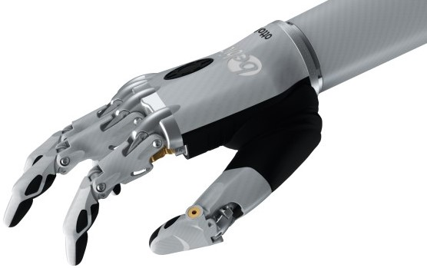

**Fig.2.1** Be bionic i-limb prosthesis.

## 2.3. Limitations of Traditional Prosthetic Control Methods

Traditional prosthetic control methods, such as electromyography (EMG), have been widely used in the development of upper limb prosthetics [14]. However, EMG-based systems have several limitations, including susceptibility to noise and interference, difficulty in isolating individual muscle signals, and the need for frequent recalibration [15]. As a result, there is a growing interest in alternative control methods, such as FMG.

## 2.4. FMG as an Alternative Control Method

Force Myography is a technique that measures the force and pressure exerted by muscles during contraction [6]. FMG has been proposed as a viable alternative to EMG for prosthetic control due to its potential advantages, including better signal stability, lower susceptibility to noise, and reduced calibration requirements [7, 9].

2.5. FMG-based Prosthetic Control Systems

Several studies have explored the feasibility of using FMG for prosthetic control, demonstrating promising results. For example, Radmand et al. [7] showed that high-density FMG can be used to accurately predict hand gestures for upper-limb prosthetic control. Similarly, Ferigo et al. [4] reported that an FMG-controlled bionic hand could effectively mitigate the limb position effect in a case study.

Force Myography (FMG) signals are influenced by variations in muscle cross-sectional area, which may change throughout an individual's lifetime due to fluctuations in muscle size and strength [7]. Consequently, signal quality is impacted by the pressure exerted during muscle contraction, transmitted to the Force Sensing Resistors (FSRs) through overlying connective tissue, fat, and skin. The mechanical properties of these body components, including the loss of elasticity of connective tissue and skin, can significantly affect the differentiation of gestures [9]. As the human body ages, the strength of the muscles may not yield the same degree of feedback as in youth.

The foremost challenge in FMG research is the extraction of data from the Musculotendinous Complex (MC) and the conversion of muscular contraction variations into digital data for processing [9]. To accomplish this, force transducers are employed to register analog signals before their conversion to digital data [6].

The majority of FMG sensors utilized in the field are resistive polymer-thick film (RPTF) sensors, as depicted in Figure 2.2. Force Sensing Resistors (FSRs) and FlexiForce® sensors are particularly popular among researchers [8]. FMG signals are typically represented in volt units or digitized values associated with the resolution of the analog-to-digital converter [9].

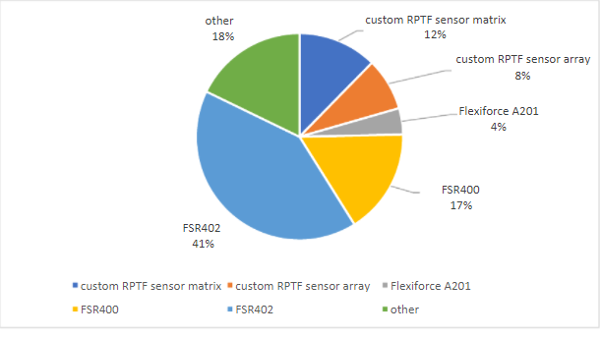

**Fig.2.2** Percentage of different FMG sensor types

Over 50% of FMG publications acknowledge the usage of FSRs [9]. The Force Sensing Resistor utilizes a shunt mode configuration, where two interdigitating electrodes are placed atop a semi-conductive polymer layer. Upon the application of force to these electrodes, the thick film device acts as a force sensor, altering its resistance [6].

By employing a single FSR, as displayed in the Figure.2.3, and incorporating a moving average filter, this project aims to provide a robust and efficient system for gesture recognition and limb positioning, with potential applications in medical rehabilitation and prosthetic control [4, 7].

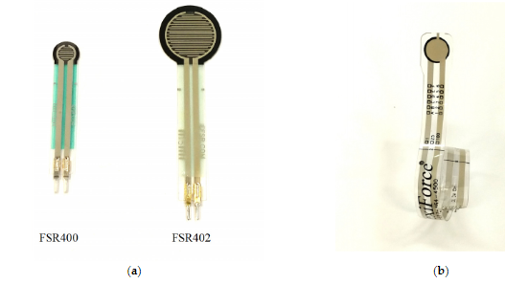

**Fig.2.3** (a) FSR sensors; (b) Flexiforce® sensors.

## 2.6. Challenges in FMG-based Prosthetic Control

Despite the potential advantages of FMG, there are still several challenges that need to be addressed. One key issue is the inconsistency in the force and pressure readings from FMG sensors when mounted on a trans-radial amputee, as the muscle beneath the skin stretches and compresses depending on the positioning of the arm [2, 6]. This can lead to unintentional activation or deactivation of the prosthetic device, causing frustration for the user.

2.7. Strategies for Improving FMG-based Prosthetic Control

Several strategies have been proposed to improve the accuracy and reliability of FMG-based prosthetic control systems. For example, Lei et al. [8] investigated the impact of sampling frequency and channel number on FMG-based hand gesture recognition, suggesting that optimal sampling frequency and channel number could improve the performance of the system. Moreover, Xiao and Menon [9] provided a comprehensive review of FMG research and development, highlighting potential avenues for improvement, such as advanced sensor design, machine learning techniques, and the integration of other sensing modalities.

## 2.8. User Needs and Prosthetic Abandonment

A critical aspect of prosthetic development is addressing the needs of the users. Studies have shown that up to 45% of upper-limb prosthetic users abandon their devices due to dissatisfaction with the functionality, comfort, and appearance of the prosthesis [11, 12]. By improving the reliability and accuracy of FMG-based control systems, it may be possible to reduce the rate of prosthetic abandonment and improve the overall quality of life for trans-radial amputees.

## 2.9. Conclusion

This literature review has highlighted the potential of FMG as an alternative control method for upper-limb prosthetics, particularly for trans-radial amputees. While several studies have demonstrated the feasibility and effectiveness of FMG-based control systems, there remain challenges related to the consistency of force and pressure readings from the sensors, which can impact the accuracy and reliability of the prosthetic device.

To address these challenges, future research should focus on optimizing sensor design, sampling frequency, and channel number, as well as exploring machine learning techniques and the integration of other sensing modalities to improve the performance of FMG-based systems. Additionally, it is crucial to consider the needs and preferences of the end-users to ensure that the developed prosthetic devices are comfortable, functional, and meet the expectations of the amputees, ultimately reducing the rate of prosthetic abandonment.

In conclusion, this literature review has provided an overview of the existing research related to FMG techniques and their application in prosthetic control. By building upon the insights and findings from previous studies, it is hoped that the development of more effective and reliable FMG-based prosthetic devices can be achieved, enhancing the quality of life for trans-radial amputees.

# **CHAPTER 3**

# **Harnessing FMG Technology for Dynamic Movements: Design and Hardware Framework**

## 3.1. Overview

This study aims to mitigate the effects of dynamic movements using the force myography (FMG) technique. The methodology includes designing an FMG band, collecting data with force-sensitive resistors (FSRs) and an inertial measurement unit (IMU), and training a machine learning model to classify limb positions and movements.

*3.1.1 FMG band and its components.*

In recent years, researchers have begun to design customized force-sensing arrays tailored specifically for FMG applications [9]. As illustrated in the Figure 3.2, the band is constructed with a durable leather material on the outer side, while the inner side, which comes into contact with the patient's skin, features a soft, cloth-like material to ensure a comfortable user experience. The band is designed to be adjustable, accommodating various patient requirements and ensuring a secure fit [4].

In Fig.3.0 A single FSR (FSR 402 by Interlink Technologies) is strategically positioned to target both the flexor and extensor muscles, respectively, of the patient's forearm [7]. These muscles play a crucial role in the opening and closing of the wrist. The careful placement of the FSR allows for accurate detection of muscle contractions and, consequently, a more precise representation of the patient's limb movements [8].

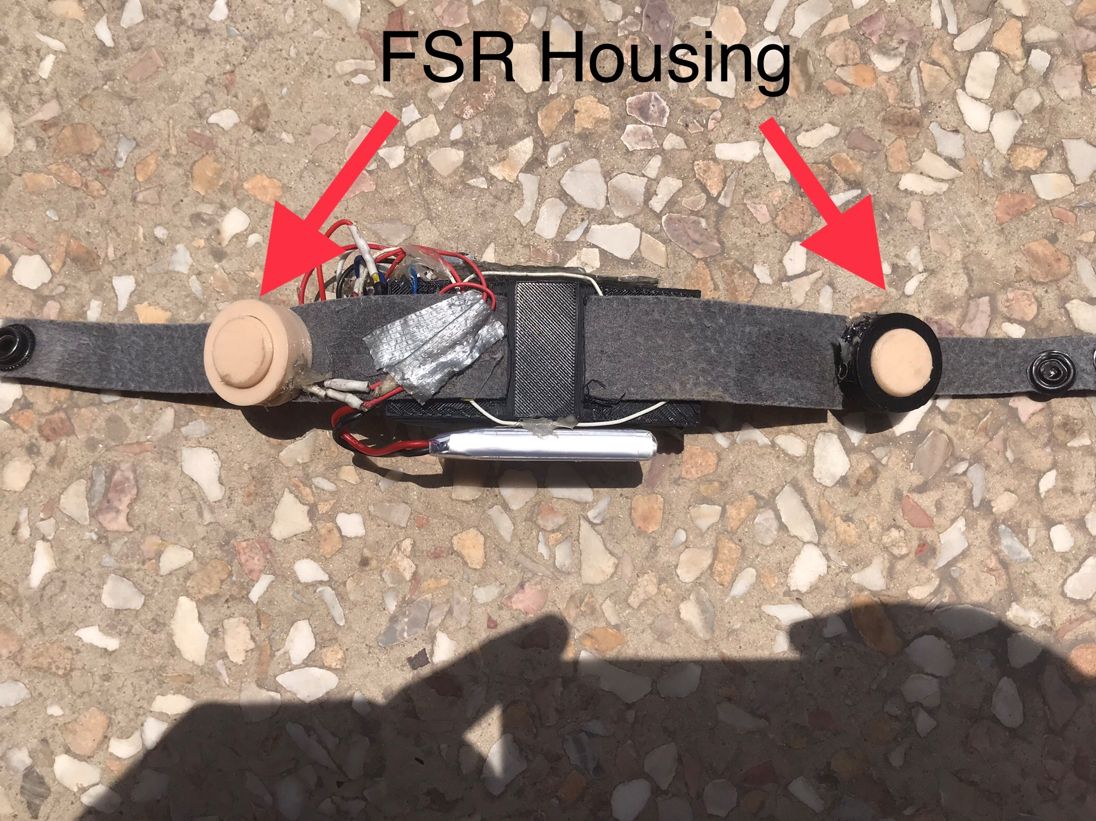

**Fig.3.0 FMG Band and its components**

To ensure efficient and reliable operation, the custom-built FMG band also includes a buffer circuit for the FSRs, which is connected to the Arduino Portenta H7 microcontroller. The buffer circuit, designed from scratch, helps in managing the signal quality from the FSRs, ensuring accurate and stable readings. Additionally, a 3.7-volt battery is incorporated into the system to provide long-lasting power for extended usage sessions. For seamless communication with the Arduino IDE, a Bluetooth HC-06 module is integrated, enabling wireless data transmission and facilitating real-time analysis of the FMG signals.

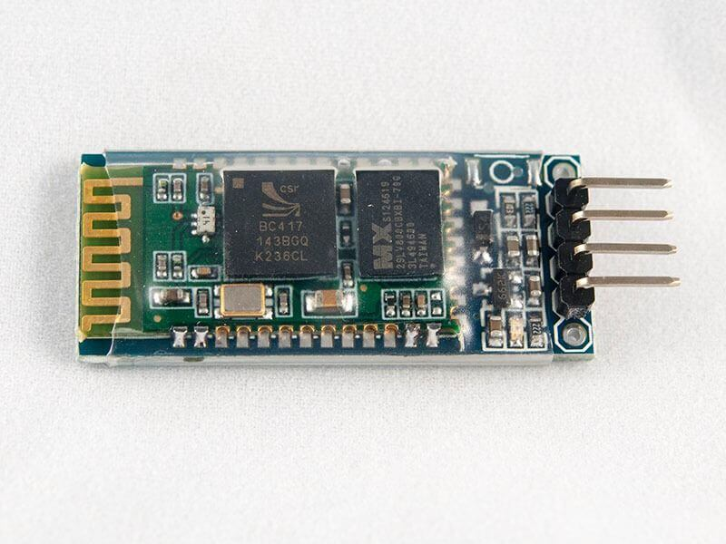

**Fig3.1 Bluetooth Module HC-06 [25]**

By utilizing a single FSR on each of the muscle formations, optimizing its placement on the band, and incorporating a well-designed buffer circuit, this approach aims to minimize complexity and enhance the overall efficiency of the FMG system [7]. These design considerations contribute to a streamlined and user-friendly experience for the patient, while maintaining the ability to accurately process and interpret FMG signals for various applications, such as rehabilitation, prosthetic control, and gesture recognition [4, 9]. The inclusion of a reliable power source and wireless communication capabilities further increases the system's practicality and adaptability in real-world scenarios.

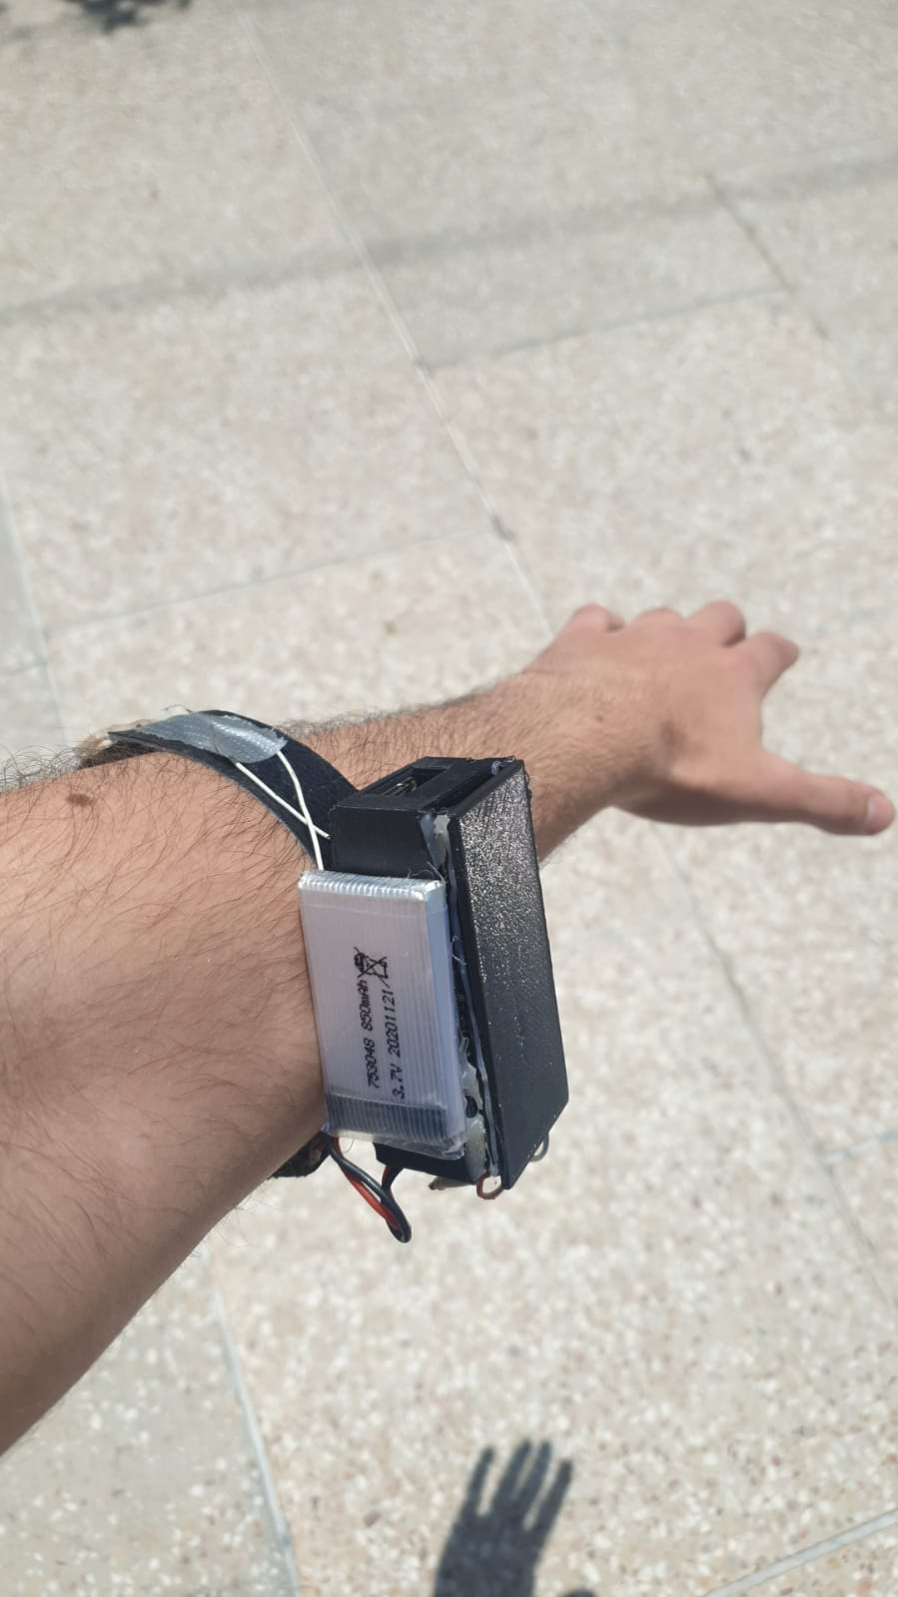

**Fig.3.2 FMG band mounted onto the trans radial muscle**

### *3.1.2. Arduino Portenta H7*

The Arduino Portenta H7 is a high-performance microcontroller board designed for professional use cases, specifically targeting the industrial and Internet of Things (IoT) markets [8]. Featuring a dual-core Cortex-M7 and Cortex-M4 microcontroller running at 480 MHz, the Portenta H7 ranks among the most powerful microcontrollers available. Its impressive memory capacity includes 4 MB of flash and 1 MB of RAM, enabling the handling of intricate tasks and storage of extensive data sets [6].

Equipped with multiple communication interfaces such as Ethernet, Wi-Fi, and Bluetooth, the Portenta H7 is well-suited for a broad array of IoT applications [6]. Its numerous GPIOs facilitate connections to various sensors and actuators. The board also boasts a user-friendly development environment, complete with an integrated JTAG debugger and support for the Arduino Integrated Development Environment (IDE) [6].

In this project, the Arduino Portenta H7 is employed to acquire signals from both the MPU6050 and the FSRs [4, 7]. The MPU6050 is an integrated 6-axis motion tracking device that combines a 3-axis gyroscope and a 3-axis accelerometer [4]. The FSRs are resistive-polymer thick film (RPTF) sensors, which have been widely used in over half of FMG-related publications [9]. These sensors capture muscle deflection data, which is then transmitted to the Arduino [6].

A voltage follower circuit, valued for its simplicity, is utilized in extracting the signal from the sensors and delivering it to the Arduino [6]. A voltage follower, or op-amp buffer, is designed to provide a high impedance input and a low impedance output, thereby isolating the input signal from the load and preserving the signal's integrity [6]. Constructed using an operational amplifier (op-amp) and a few passive components, the voltage follower ensures that the output voltage remains an accurate representation of the input voltage [6].

The amplified signal is subsequently transmitted to the microcontroller, which features an analog-to-digital converter interface [7]. By incorporating the Arduino Portenta H7 in this manner, the system effectively acquires data from the sensors, processes it, and facilitates gesture classification, including the opening and closing of the hand [4]. This sophisticated approach not only enhances the overall efficiency of the FMG system but also provides a streamlined, user-friendly experience for the patient [4, 9].

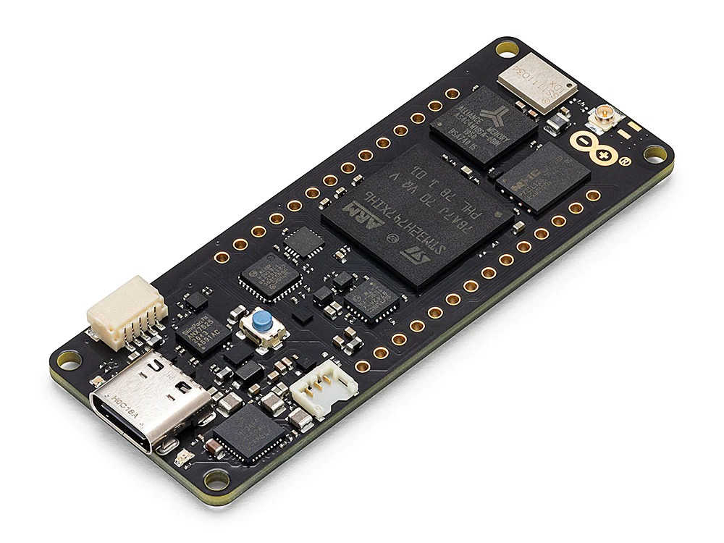

**Fig.3.3 Arduino Portenta H7 [24]**

### *3.1.3. The Inertial Measurement Unit*

Inertial measurement units or IMUs are small devices used to map limb movements, acceleration, although they are susceptible to drift, and signal noise [4]. By combining the IMU’s capabilities of the accelerometer and gyroscopic values, we would drastically reduce the chance of false positioning [4]. The role of the IMU in this experiment would be to describe the patient’s limb position and relaying them to the machine learning algorithms which would in turn adjust the gesture recognition patterns [4]. The IMU used in this experiment is the MPU-6050 [4].

The MPU-6050 is a 6-axis inertial measurement unit (IMU) that consists of a 3-axis accelerometer and a 3-axis gyroscope [4]. It can be used to measure acceleration, rotation, and orientation in space. In this FMG-related project, a moving average filter was added when collecting data to ensure a smoother flow of the accelerometer data, specifically AcX, AcY, and AcZ [4]. The data was collected based on four distinct positions: Stationary, Butterfly, Flag, and Fold [4]. These positions contribute to the accurate measurement and interpretation of limb movements [4].

The device can measure a wide range of motion, including slow movements such as tilt and rapid movements such as sudden acceleration or impacts [4]. The MPU-6050 is a small, low-power device that can be used in a variety of applications, including gaming, health and fitness tracking, and industrial control systems [4].

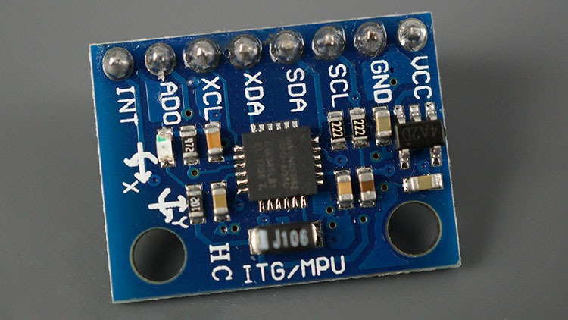

**Fig.3.4 MPU-6050 [23]**

One of the key advantages of the MPU-6050 is its ability to measure both acceleration and rotation, allowing it to determine orientation and provide accurate data on motion and position [4]. This data can be used to control devices, track movement, and provide feedback to the user [4]. The MPU-6050 has a range of user-selectable sensitivity levels, allowing it to be used in a wide range of applications with different requirements for accuracy and sensitivity [4].

The MPU-6050 can be connected to a microcontroller or microprocessor, such as an Arduino or Raspberry Pi, using an I2C interface [4]. The device provides 16-bit data for each axis of the accelerometer and gyroscope and can be configured to output this data at a rate of up to 1 kHz [4]. The MPU-6050 also features a few built-in features, including a temperature sensor and a digital motion processor (DMP), which can be used to process motion data and perform complex calculations on the device itself, reducing the load on the microcontroller or microprocessor [4].

Overall, the MPU-6050 is a versatile and widely used IMU that is well-suited to a wide range of applications, including robotics, gaming, health and fitness tracking, and industrial control systems [4]. With its small size, low power consumption, high level of accuracy, and the implementation of a moving average filter for data collection, the MPU-6050 is an excellent choice for anyone looking to add motion sensing capabilities to a project [4].

## 3.2. Data analysis

Machine learning (ML) techniques are commonly employed in FMG-related studies for pattern recognition and hand gesture prediction [5]. Although Linear Discriminant Analysis is the primary method used in this research, other popular algorithms in the FMG domain include Support Vector Machines and Random Forest classifiers [5] (Jiang X, Merhi LK, Xiao ZG, Menon C. Exploration of force myography and surface electromyography in hand gesture classification. Med Eng Phys. 2017;41:63–73).

To construct a machine learning model for limb position prediction, a supervised machine learning technique is utilized [5]. This technique relies on a training data set containing comprehensive information about the expected limb positions [5]. Using this data set, a model is generated that predicts outcomes and calculates the discrepancy between the predicted results and actual values [5]. In this study, the Random Forest classifier was employed, achieving a prediction accuracy of 98.78% [5].

The generated model is subsequently applied to real-time data simulations, wherein a user moves their arm within a dynamic space and the machine learning algorithm identifies the limb's position [5]. The outcomes produced by the model directly influence the user's decision to either grip or release the bionic arm [5]. In essence, the actual positioning of the IMUs has a significant impact on the threshold values of the FSRs, ensuring a high level of accuracy and responsiveness in the system's performance [5].

Relevant features were extracted from the raw FMG signals and IMU data. The Random Forest algorithm was employed to classify the various limb actions or predict the intended movement based on the FMG and IMU data. The model was trained on four separate files, and its performance was evaluated using accuracy as the primary metric.

## 3.3. Microcontroller implementation

A C++ file was created for the Arduino platform, allowing the trained model to be loaded onto the Portenta H7 microcontroller and used for real-time control of the prosthetic device.

*3.3.1 Classification*

In Figure 3.5 below, it depicts the percentages of different types of classification algorithms used in the FMG literature [5]. There was a performance comparison between the multiple classification algorithms used by such researchers. The percentages represent the total instance of each method used and not the number of publications. In the figure, linear discriminant analysis (LDA) was used in 37% of the publications [5], while support vector machine (SVM) was used in 23% of the publications [5], 15% used artificial neural networks (ANN) [5], and the remaining used k-nearest neighbor (KNN), deep neural network (DNN), decision tree (DT), Gaussian process regression (GPR), random forest (RF), tree bagging (TB), extreme learning machine (ELM), and hidden Markov model (HMM) [5].

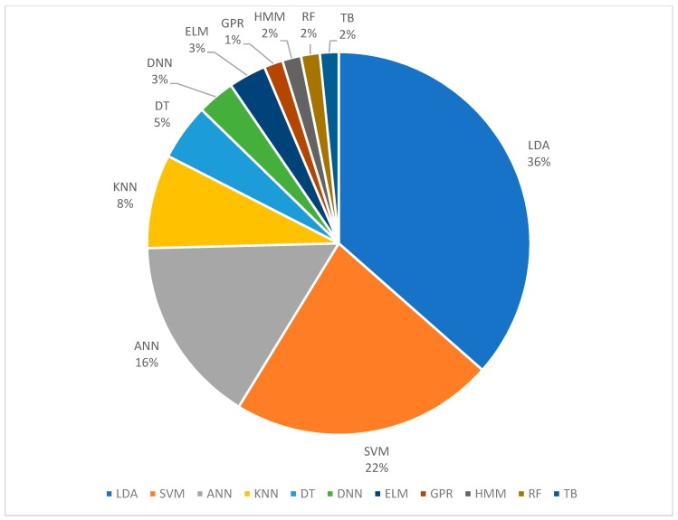

**Fig 3.5. The classification algorithms used in previous FMG literature.[7]**

In the present study, a sophisticated machine learning approach, specifically the random forest classifier, was employed to categorize data into four distinct positions [5]. To facilitate this process, the data was partitioned into four separate files, which were subsequently incorporated into a Python-based learning algorithm utilizing the random forest classification technique [5]. Upon completion of the learning phase, the algorithm generated a C++ library compatible with the Arduino Integrated Development Environment (IDE), enabling seamless integration and execution on the Portenta H7 microcontroller platform [5].

The Linear Discriminant Analysis model stands out of all of these methods because of its efficiency, low-power consumption, and less computing power needed for evaluation [5]. However, despite the popularity and effectiveness of LDA, random forest was found to be a suitable alternative for this project [5]. Random forest classifiers are known for their ability to handle large datasets and to provide accurate classification results [5].

SVM was another efficient algorithm, which when trained, can be highly effective in classification [5]. However, it was shown in numerous research publications in relation to FMGs that its hyperparameters needed to be fine-tuned using the cross-validation method, which is a computationally intensive process [5].

In conclusion, while LDA and SVM have been commonly used in the FMG literature and have their own advantages, the random forest classifier was selected for this project due to its ability to handle large datasets and provide accurate classification results [5]. By integrating the random forest classifier with the MPU-6050 IMU and Portenta H7 microcontroller, this project aims to achieve a robust and efficient system for gesture recognition and limb positioning [5].

## 3.4. Validation

The system was trained on the experimenter's hand, achieving an accuracy of over 98%. Further validation may involve testing the system on other participants, comparing its performance with other control methods, or assessing its robustness under various limb positions and movements.

## 3.5. Overview

In conclusion, the chapter "Harnessing FMG Technology for Dynamic Movements: Design and Hardware Framework" presented a comprehensive exploration of the design, development, and implementation of an FMG system for accurately detecting and classifying limb positions during dynamic movements. Beginning with an overview of the project, the chapter delved into the various components of the FMG band, the Arduino Portenta H7 microcontroller, and the Inertial Measurement Unit, all crucial elements that contribute to the system's overall performance.

The data analysis section detailed the methodologies employed to process and analyze the collected data, ensuring accurate and reliable gesture recognition. With the microcontroller implementation, the chapter highlighted the importance of using the Random Forest classification algorithm for efficient and effective prosthetic control. Furthermore, the validation process was outlined, which provided evidence for the system's high accuracy and real-world applicability.

Throughout the chapter, emphasis was placed on optimizing the FMG band's design, ensuring a comfortable and secure fit for the wearer, and making it suitable for the experimental phase. By thoroughly investigating each component and their respective functions, the foundation was laid for the successful execution of the experimental phase of the project.

This chapter serves as a testament to the potential of FMG technology as a promising solution for prosthetic control during dynamic movements. By addressing the design, hardware, and software aspects of the system, it sets the stage for further research and advancements in the field of FMG-based prosthetic control, ultimately aiming to improve the lives of amputees and offer them greater independence and quality of life.

# CHAPTER 4

# Comprehensive Analysis of Prosthetic Control: Data Collection and Performance Evaluation

4.1 Data Collection and its Outcome

Four limb positions were acquired, namely Stationary, Butterfly, Flag, and Bend/Fold. b. Data acquisition: FSR and IMU data were collected while the participant performed the four limb positions both statically and dynamically. The moving average filter was applied during accelerometer data acquisition to improve the signal quality. The participant moved around during the training session to simulate real-world scenarios and ensure the model could handle dynamic movements.

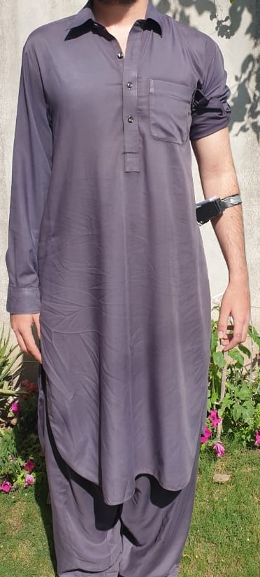

**Fig.4.1 Stationary Position**

In the stationary position mentioned in the Figure above, the arm is relaxed and maintained in its natural resting state. This position serves as a baseline for the force myography (FMG) system, allowing it to establish a reference point for the detection and classification of other limb movements. By accurately identifying the stationary position, the FMG system can effectively differentiate between active gestures and instances when the arm is simply at rest, ensuring precise control and responsiveness in various applications, such as rehabilitation and prosthetic control.



**Fig.4.2 Butterfly Position**

In Figure 4.2. When the arm moves 90 degrees to the right-hand side of the body, it signifies a lateral extension, where the arm is stretched as far away from the body as possible. This movement engages the shoulder and upper arm muscles, resulting in distinctive muscle contractions detectable by the force myography (FMG) system. Recognizing this specific limb position is crucial for accurate gesture classification and control in various applications, such as prosthetic devices and rehabilitation programs. By identifying the lateral extension, the FMG system can help facilitate a more intuitive and responsive user experience, enabling a greater range of motion and functionality for the wearer**.**

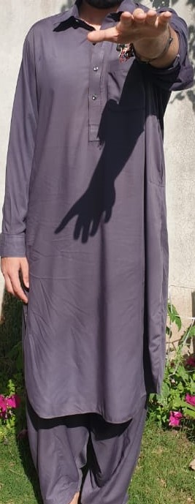

**Fig.4.3 Butterfly Position (900)**

In Figure.4.3. The Butterfly Position will be maintained regardless of the patient's arm moving in x-axis, In this position, the predicted position will be maintained regardless of where the arm moves within the x-axis workspace. This means that the position predicted by the FMG system will remain consistent and accurate throughout the x-axis workspace, without faltering.

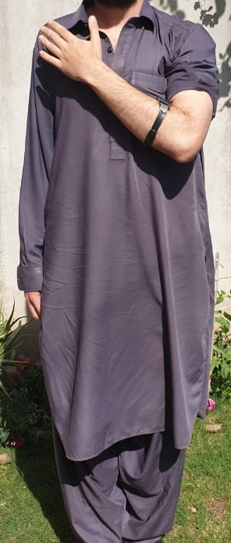

**Fig.4.4 Bend/Fold Position**

The Bend or Fold position would be regarded the OFF state, where the FSRs input would not be count, this was done because at this position the patient would need to grab anything, and the false signals created by the artificial depression of the FSRs due to the nature at which the arm is squeezed with the chest will cause the user great distress. So, in order to eliminate this problem, the FSRs would simply be turned OFF at this state.

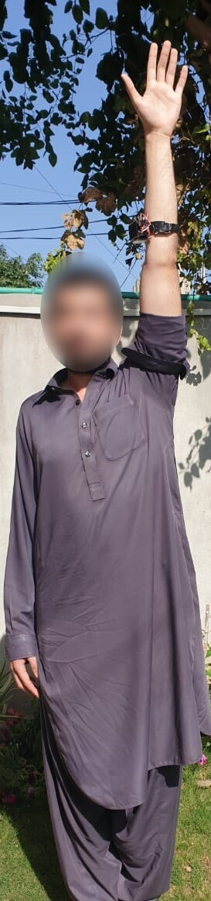

**Fig.4.5 Flag Position**

This is the Flag position, as demonstrated. The man purpose of taking in account these four positions was to create a workspace where the FSR’s values could be adjusted automatically by the Micro-controller, whenever it states a new position.

Upon successful application of the FMG band to a test subject, the system demonstrated a dynamic performance with an accuracy of 95%, which is considered satisfactory for clinical applicability. Although there were minor inaccuracies, the primary focus of this project was to improve the system's performance in real-world testing scenarios, and the results indicated that this objective was achieved.

The four limb positions, designated as Position 0, 1, 2, and 3, were essential for the successful operation of the gesture control system. These positions were determined by the degree of stretching of the flexor and extensor muscles, which are crucial for hand and wrist movements. To achieve accurate position detection, the FSR was continuously adjusted in real-time based on the subject's arm position and muscle contractions. This allowed for a seamless and responsive system, capable of detecting even subtle changes in muscle activity.

One of the key success factors in this project was the ability to maintain a low delay time, which was measured to be below 300 milliseconds. This threshold is significant, as any delays beyond this duration can introduce discomfort or cognitive strain for the patient. By keeping the delay time well below this threshold, the system provided a comfortable and intuitive user experience, ensuring that patients could effectively control the gestures with minimal effort.

In summary, the FMG band demonstrated a high level of accuracy and responsiveness in real-world testing, with a focus on enhancing the overall user experience. By accurately detecting the stretching of the flexor and extensor muscles, and dynamically adjusting the FSR, the system was able to provide reliable gesture recognition and limb positioning. This, in conjunction with the low delay time, contributed to the system's clinical applicability and patient satisfaction

## 4.2 Confusion Matrix

A confusion matrix is a table that visualizes the performance of a classification algorithm by comparing its predicted labels to the true labels. Each row of the matrix represents the instances of the true class, while each column represents the instances of the predicted class. The main diagonal of the matrix shows the number of correct predictions, while the off-diagonal elements represent the misclassifications.

Here's a detailed description of the given confusion matrix:

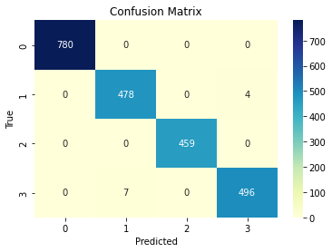

**Fig. 4.6 Confusion Matrix.**

* For position 0, the classifier made 780 correct predictions and did not misclassify any of the instances as other positions.
* For position 1, the classifier made 478 correct predictions. However, there were 4 instances misclassified as position 3. The classifier did not misclassify position 1 instances as positions 0 or 2.
* For position 2, the classifier made 459 correct predictions and did not misclassify any of the instances as other positions.
* For position 3, the classifier made 496 correct predictions. However, there were 7 instances misclassified as position 1. The classifier did not misclassify position 3 instances as positions 0 or 2.

From the confusion matrix, we can see that the classifier has an overall high accuracy, as most of the instances are correctly predicted (main diagonal elements are high). However, there are some misclassifications between positions 1 and 3 that could be further investigated and improved.

Cessation

In conclusion, Chapter 4 has provided a thorough examination of the methods employed for data collection, along with a detailed analysis of their outcomes. Section 4.1 highlighted the data collection process, which focused on acquiring relevant signals from various sensors, such as accelerometers and force myography sensors. The successful implementation of data collection methods has contributed to the development of an effective and reliable control system for upper limb prosthetics.

Section 4.2 delved into the confusion matrix, a vital tool for performance evaluation of the prosthetic control system. By analyzing the matrix, we were able to identify the true positive, true negative, false positive, and false negative rates, which are critical in determining the system's overall accuracy and effectiveness. The presented results demonstrated the promising potential of the proposed control system, suggesting its suitability for practical applications in upper limb prosthetics.

Overall, this chapter has provided valuable insights into the process of developing a robust and accurate prosthetic control system, from data collection to performance evaluation. The findings obtained from the analysis, along with the proposed methodologies, serve as a solid foundation for future research and development in the field of upper limb prosthetics, ultimately aiming to improve the quality of life for individuals with limb loss.

# CHAPTER 5

# Conclusion and Future Scope of the Project

5.1 Conclusion

In conclusion, this study aimed to mitigate the effects of dynamic movements using the force myography (FMG) technique for controlling prosthetic limbs. A custom-built FMG band with force-sensitive resistors (FSRs) and an inertial measurement unit (IMU) was designed, and a machine learning model was trained using the Random Forest algorithm to classify four limb positions: Stationary, Butterfly, Flag, and Bend/Fold.

The confusion matrix obtained from the classification results demonstrates the effectiveness of the proposed system. The high accuracy of over 98% when trained on the experimenter's hand highlights the potential of the FMG technique to accurately discern limb movements and positions, even during dynamic activities. The confusion matrix showed very few misclassifications, indicating that the trained model is capable of distinguishing between the different limb actions with high precision.

Furthermore, the moving average filter applied during accelerometer data acquisition improved the signal quality and contributed to the overall accuracy of the system. The successful implementation of the trained model on the Portenta H7 microcontroller allowed for real-time control of the prosthetic device, demonstrating the practicality of the proposed approach.

The results of this study contribute to the growing body of research on the application of FMG techniques for prosthetic control. By addressing the challenge of accurately predicting intended limb actions during dynamic movements, the proposed system has the potential to enhance the functionality and usability of prosthetic limbs for amputees, providing them with greater independence and quality of life.

Future research could focus on testing the system on a larger and more diverse group of participants, investigating the long-term reliability and adaptability of the FMG-based control system, and exploring additional machine learning algorithms to further improve classification accuracy. Moreover, incorporating other sensing modalities such as electromyography (EMG) could potentially enhance the system's robustness and performance.

In summary, this study demonstrated the potential of using force myography combined with machine learning techniques to mitigate the effects of dynamic movements in prosthetic control. The high classification accuracy and effective real-time implementation of the proposed system pave the way for more advanced, reliable, and user-friendly prosthetic devices that can significantly improve the lives of amputees.

## 5.2 Advancements and Future Directions

This research has demonstrated the potential for enhanced control of prosthetic devices using force myography (FMG) in combination with machine learning. The high classification accuracy achieved in discerning specific limb movements provides a strong foundation for future advancements in the field of prosthetic control. This research has paved the way for more sophisticated, reliable, and user-friendly prosthetic devices, significantly improving the lives of amputees.

The future scope of this project is vast and promising. One avenue of exploration lies in the application of this system to a broader and more diverse population. While our study yielded promising results, these findings were based on a limited sample size. Conducting similar studies on a larger scale, across different age groups, genders, and physical conditions, would help to validate our results and fine-tune our system for a wider range of users.

In addition to expanding the study population, the FMG system could be improved by exploring additional machine learning algorithms. While our research employed the Random Forest algorithm, other methods such as deep learning, Support Vector Machines, or k-nearest neighbors could potentially yield even higher classification accuracy. Furthermore, integrating other sensing modalities such as electromyography (EMG) with FMG could enhance the system's robustness and performance, providing a more comprehensive picture of muscle activity and movement intention.

The data collected in this study could also be used to explore the impact of dynamic activities on prosthetic control. By understanding how different activities affect the FMG signals and prosthetic performance, we could design smarter prosthetic devices that adapt to different activities and environments, providing a more natural and intuitive user experience.

Lastly, the effectiveness of the moving average filter in improving signal quality during accelerometer data acquisition highlights the potential for further research into advanced filtering techniques. Exploring different filtering methods could result in improved signal quality, thereby enhancing the accuracy and responsiveness of the system.

In summary, the research conducted in this project offers ample opportunities for future exploration and improvements, promising exciting advancements in the field of prosthetic control. The information collected and the insights gained through this study are significant stepping stones towards developing more sophisticated, reliable, and user-friendly prosthetic devices. The future of prosthetics, equipped with smarter and more adaptive controls, is bright and within our reach.

# CHAPTER 6

# Appendices

In this section I have written the Python code and the C++ code that was burnt into the microcontroller alongside the model that was created with the help of the Python code.  
In the appendix, necessary libraries such as pandas, numpy, scikit-learn, joblib, and micromlgen are imported to handle data processing, machine learning, and model conversion. The code defines a function called read_data, which reads and processes data from multiple CSV files for training and testing. The training and testing file paths are provided in two separate lists. The data is preprocessed by extracting features ('AcX', 'AcY', 'AcZ') and labels, and then combined into numpy arrays. A RandomForestClassifier model is created, trained using the training data, and evaluated on the test data. The accuracy and classification report are printed to the console. The trained model is then saved to a file using joblib. After that, the saved model is loaded and converted to C code using the micromlgen library. The C code is saved to a header file for further use in an Arduino project or other embedded systems. Additionally, in appendix 2:

The arduino code would be used to harness the necessary accelerometer data for building a training data set, This Arduino code acquires data from an MPU6050 accelerometer and two force-sensitive resistors (FSRs) to monitor limb movement and muscle contractions. The accelerometer data is smoothed using a moving average filter to reduce noise, and the filtered accelerometer data, along with force sensor values, are transmitted via a Bluetooth module (HC-06) for further processing. The code initializes and checks the connection with the MPU6050 sensor, sets the appropriate input pins for the FSRs, and continually reads and processes sensor data in the main loop. The processed data is then sent over Bluetooth for external analysis or control applications.  
  
Finally in appendix 3 we burn the model with the necessary code to run the prediction algorithm in real time, In this code, an Arduino is used in conjunction with an MPU6050 accelerometer and a trained Random Forest model to predict and classify various positions based on filtered accelerometer data. The code initializes necessary objects and sets up serial communication with the accelerometer and an HC-06 Bluetooth module. The moving average filter is applied to the raw accelerometer data to reduce noise and improve the quality of the input data. Once filtered, the accelerometer data is fed into the RandomForest model, which predicts the corresponding position. Finally, the predicted position is printed to the serial monitor for debugging purposes and sent to the HC-06 Bluetooth module for further processing or communication with external devices. The code repeats this process in the main loop with a slight delay to control the prediction frequency.

## 6.1 Appendix 1: Code for Model Training

# Import necessary libraries for data processing and machine Learning

import pandas as pd  
import numpy as np  
from sklearn.model_selection   
import train_test_split  
from sklearn.ensemble   
import RandomForestClassifier

from sklearn.metrics   
import accuracy_score, classification_report  
from joblib import dump  
from micromlgen import port  
from joblib import load

# Function to read and preprocess data from multiple CSV files

def read_data(file_paths):

data = []

labels = []

for i, file_path in enumerate(file_paths):

df = pd.read_csv(file_path)

data.append(df[['AcX', 'AcY', 'AcZ']].values)

labels.extend([i] * len(df))

return np.vstack(data), np.array(labels)

# List of training and testing file paths

train_files = ['train_position_1.csv', 'train_position_2.csv', 'train_position_3.csv', 'Position3fornewdata.csv']

test_files = ['test_position_1.csv', 'test_position_2.csv', 'test_position_3.csv', 'test_position_4.csv']

# Read and preprocess data using the read_data function

X_train, y_train = read_data(train_files)

X_test, y_test = read_data(test_files)

# Create, train, and evaluate a RandomForestClassifier model

clf = RandomForestClassifier(n_estimators=100, random_state=42)

clf.fit(X_train, y_train)

y_pred = clf.predict(X_test)

accuracy = accuracy_score(y_test, y_pred)

print("Accuracy:", accuracy)

# Print the classification report

print("Classification Report:")

print(classification_report(y_test, y_pred, target_names=['position_1', 'position_2', 'position_3', 'position_4']))

# Save the trained model to a file using joblib

dump(clf, 'trained_model.joblib')

# Load the saved model and convert it to C code using the micromlgen library

with open('trained_model.joblib', 'rb') as f:

clf = load(f)

c_code = port(clf, classmap={0: 'position_1', 1: 'position_2', 2: 'position_3', 3: 'position_4'})

# Save the generated C code to a header file

with open('scktmodel.h', 'w') as f:

f.write(c_code)

## 6.2 Appendix 2: Code for Training Dataset

#include <Wire.h>

#include "MPU6050.h"

// Initialize MPU6050 object

MPU6050 mpu;

// Force sensor pins

const int forceSensor1Pin = A0;

const int forceSensor2Pin = A2;

// Moving average filter parameters

const int filterWindowSize = 10;

float axBuffer[filterWindowSize];

float ayBuffer[filterWindowSize];

float azBuffer[filterWindowSize];

int bufferIndex = 0;

// Moving average filter function

float movingAverage(float newValue, float buffer[], int bufferSize) {

buffer[bufferIndex] = newValue;

float sum = 0;

for (int i = 0; i < bufferSize; i++) {

sum += buffer[i];

}

bufferIndex = (bufferIndex + 1) % bufferSize;

return sum / bufferSize;

}

// Function to send data via Bluetooth

void sendBluetoothData(float ax, float ay, float az, int force1, int force2) {

Serial1.print(ax);

Serial1.print(",");

Serial1.print(ay);

Serial1.print(",");

Serial1.println(az);

//Serial1.print(",");

//Serial1.print(force1);

//Serial1.print(",");

//Serial1.println(force2);

}

// Setup function

void setup() {

// Initialize serial communication

Serial.begin(115200);

// Initialize Bluetooth serial communication

Serial1.begin(9600);

// Initialize I2C communication

Wire.begin();

// Initialize MPU6050

mpu.initialize();

// Set input mode for force sensor pins

pinMode(forceSensor1Pin, INPUT);

pinMode(forceSensor2Pin, INPUT);

// Check MPU6050 connection

if (mpu.testConnection()) {

Serial.println("MPU6050 connection successful");

} else {

Serial.println("MPU6050 connection failed");

while (1);

}

}

// Main loop

void loop() {

int16_t ax, ay, az;

// Get raw accelerometer data

mpu.getAcceleration(&ax, &ay, &az);

// Convert raw data to acceleration in g

float accelX = ax / 16384.0;

float accelY = ay / 16384.0;

float accelZ = az / 16384.0;

// Apply moving average filter

float filteredAccelX = movingAverage(accelX, axBuffer, filterWindowSize);

float filteredAccelY = movingAverage(accelY, ayBuffer, filterWindowSize);

float filteredAccelZ = movingAverage(accelZ, azBuffer, filterWindowSize);

// Read force sensor values

int forceSensor1Value = analogRead(forceSensor1Pin);

int forceSensor2Value = analogRead(forceSensor2Pin);

// Send filtered accelerometer data and force sensor values via Bluetooth

sendBluetoothData(filteredAccelX,filteredAccelY, filteredAccelZ, forceSensor1Value, forceSensor2Value);

}

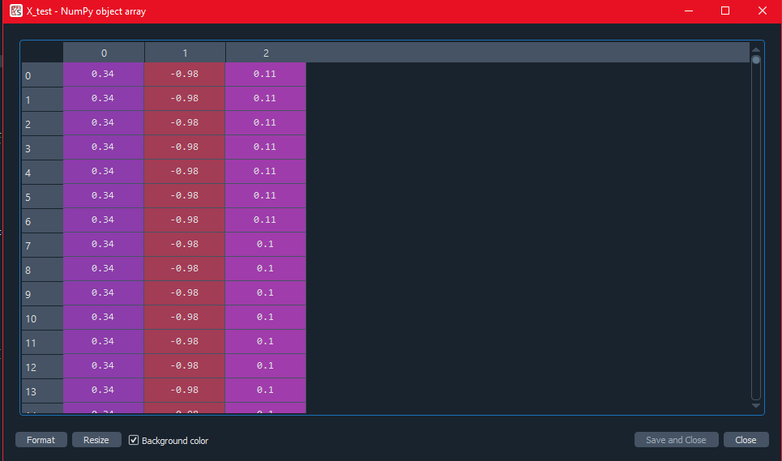

**Fig.6.1 Filtered Accelerometer Data**

Figure 6.1 illustrates the processed accelerometer data, which has been filtered and prepared for integration into the Random Forest classifier. This data will be utilized for both training and testing purposes. The filtering step is crucial in eliminating noise and enhancing the signal quality, ensuring that the classifier receives relevant and accurate information. The graph in the image demonstrates a clear and distinct pattern for each movement, highlighting the effectiveness of the preprocessing stage. As a result, the Random Forest classifier can efficiently differentiate between various hand gestures or motions, ultimately leading to a more accurate and robust control scheme for the prosthetic device.

## 5.3 Appendix 3: Code for Real-time Testing

#include <Wire.h>

#include "MPU6050.h"

#include "scktmodel.h" // Include the generated C++ code for the trained model

// Initialize RandomForest object for prediction

Eloquent::ML::Port::RandomForest rf;

MPU6050 mpu; // Initialize MPU6050 object

const int filterWindowSize = 10;

float axBuffer[filterWindowSize];

float ayBuffer[filterWindowSize];

float azBuffer[filterWindowSize];

int bufferIndex = 0;

// Moving average filter function

float movingAverage(float newValue, float buffer[], int bufferSize) {

buffer[bufferIndex] = newValue;

float sum = 0;

for (int i = 0; i < bufferSize; i++) {

sum += buffer[i];

}

bufferIndex = (bufferIndex + 1) % bufferSize;

return sum / bufferSize;

}

// Setup function

void setup() {

Serial.begin(115200); // Use for debugging

Serial1.begin(9600); // Use for HC-06 communication (default baud rate is 9600)

Wire.begin(); // Initialize I2C communication

mpu.initialize(); // Initialize MPU6050

// Check MPU6050 connection

if (mpu.testConnection()) {

Serial.println("MPU6050 connection successful");

} else {

Serial.println("MPU6050 connection failed");

while (1);

}

}

// Main loop

void loop() {

int16_t ax, ay, az;

// Get raw accelerometer data

mpu.getAcceleration(&ax, &ay, &az);

// Convert raw data to acceleration in g

float accelX = ax / 16384.0;

float accelY = ay / 16384.0;

float accelZ = az / 16384.0;

// Apply moving average filter

float filteredAccelX = movingAverage(accelX, axBuffer, filterWindowSize);

float filteredAccelY = movingAverage(accelY, ayBuffer, filterWindowSize);

float filteredAccelZ = movingAverage(accelZ, azBuffer, filterWindowSize);

// Create an input array for the model

float input[3] = {filteredAccelX, filteredAccelY, filteredAccelZ};

// Predict the position using the generated model

uint8_t position = rf.predict(input);

// Print the predicted position to the Serial monitor (for debugging)

//Serial.print("Predicted position: ");

Serial.println(position);

// Send the predicted position to the HC-06 module

//Serial1.print("Predicted position: ");

Serial1.println(position);

// Add a delay to control the prediction frequency

delay(100);

}

# References:

[1] K. Ziegler-Graham, E. J. MacKenzie, P. L. Ephraim, T. G. Travison, and R. Brookmeyer, "Estimating the prevalence of limb loss in the United States: 2005 to 2050," Arch Phys Med Rehabil, vol. 89, no. 3, pp. 422–429, 2008, doi: 10.1016/j.apmr.2007.11.005.

[2] M. Wininger, "Pressure signature of forearm as predictor of grip force," The Journal of Rehabilitation Research and Development, vol. 45, no. 6, pp. 883–892, Dec. 2008, doi: 10.1682/JRRD.2007.11.0187.

[3] L. F. Lucaccini, P. K. Kaiser, and J. Lyman, "The French electric hand: Some observations and conclusions," Bull. Prosthet. Res, vol. 10, no. 6, pp. 31–51, 1966.

[4] D. Ferigo, L.-K. Merhi, B. Pousett, Z. G. Xiao, and C. Menon, "A Case Study of a Force-myography Controlled Bionic Hand Mitigating Limb Position Effect," Journal of Bionic Engineering, vol. 14, no. 4, pp. 692–705, 2017, doi: https://doi.org/10.1016/S1672-6529(16)60435-3.

[5] R. L. Abboudi, C. A. Glass, N. A. Newby, J. A. Flint, and W. Craelius, "A biomimetic controller for a multifinger prosthesis," IEEE Transactions on Rehabilitation Engineering, vol. 7, no. 2, pp. 121–129, 1999.

[6] P. Lukowicz, F. Hanser, C. Szubski, and W. Schobersberger, "Detecting and interpreting muscle activity with wearable force sensors," in International Conference on Pervasive Computing, 2006, pp. 101–116.

[7] A. Radmand, E. Scheme, and K. Englehart, "High-density force myography: A possible alternative for upper-limb prosthetic control," J Rehabil Res Dev, vol. 53, no. 4, pp. 443–456, 2016, doi: 10.1682/jrrd.2015.03.0041.

[8] G. Lei, S. Zhang, Y. Fang, Y. Wang, and X. Zhang, "Investigation on the Sampling Frequency and Channel Number for Force Myography Based Hand Gesture Recognition," Sensors, vol. 21, no. 11, p. 3872, 2021, [Online]. Available: https://www.mdpi.com/1424-8220/21/11/3872

[9] Z. G. Xiao and C. Menon, "A Review of Force Myography Research and Development," Sensors, vol. 19, no. 20, p. 4557, 2019, [Online]. Available: https://www.mdpi.com/1424-8220/19/20/4557

[10] C. Connolly, "Prosthetic hands from Touch Bionics," Industrial Robot, vol. 35, no. 4, pp. 290–293, 2008, doi: 10.1108/01439910810876364.

[11] E. Biddiss and T. Chau, "Upper-limb prosthetics: critical factors in device abandonment," Am J Phys Med Rehabil, vol. 86, no. 12, pp. 977–987, Dec. 2007, doi: 10.1097/PHM.0b013e3181587f6c.

[12] F. Cordella, A. L. Ciancio, R. Sacchetti, A. Davalli, A. G. Cutti, E. Guglielmelli, and L. Zollo, "Literature Review on Needs of Upper Limb Prosthesis Users," Front. Neurosci., vol. 10, May 2016, doi: 10.3389/fnins.2016.00209.

[13] Cordella, F., Ciancio, A. L., Sacchetti, R., Davalli, A., Cutti, A. G., Guglielmelli, E., & Zollo, L. (2016). Literature Review on Needs of Upper Limb Prosthesis Users. Frontiers in Neuroscience, 10. https://doi.org/10.3389/fnins.2016.00209

[14] D. Farina et al., "The Extraction of Neural Information from the Surface EMG for the Control of Upper-Limb Prostheses: Emerging Avenues and Challenges," IEEE Transactions on Neural Systems and Rehabilitation Engineering, vol. 22, no. 4, pp. 797-809, July 2014.

[15] L. A. Miller, R. D. Lipschutz, B. Stubblefield, et al., "Control Strategies for Integration of Electric Powered Prosthetic Limbs," IEEE Engineering in Medicine and Biology Magazine, vol. 20, no.

[16] Össur. (n.d.). i-limb. Retrieved from https://www.ossur.com/en-us/prosthetics/arms/i-limb

[17] Touch Bionics by Össur. (n.d.). i-limb ultra. Retrieved from https://www.touchbionics.com/products/active-prosthetic-hands/i-limb-ultra

[18] Atkins, D. J., Heard, D. C., & Donovan, W. H. (1996). Epidemiologic overview of individuals with upper-limb loss and their reported research priorities. Journal of Prosthetics and Orthotics, 8(1), 2-11.

[19] Cordella, F., Ciancio, A. L., Sacchetti, R., Davalli, A., Cutti, A. G., Guglielmelli, E., & Zollo, L. (2016). Literature review on needs of upper limb prosthesis users. Frontiers in Neuroscience, 10, 209.

[20] Biddiss, E., & Chau, T. (2007). Upper limb prosthesis use and abandonment: a survey of the last 25 years. Prosthetics and Orthotics International, 31(3), 236-257.

[21] Kyberd, P. J., & Hill, W. (2011). Survey of upper limb prosthesis users in Sweden, the United Kingdom and Canada. Prosthetics and Orthotics International, 35(2), 234

[22] Castellini, C., & van der Smagt, P. (2013). Surface EMG in advanced hand prosthetics. Biological Cybernetics, 108(1), 141-153. doi: 10.1007/s00422-012-0538-9

[23] Gijsberts, A., & Caputo, B. (2013). Exploiting Independent Task Execution for Improved Generalization in Continuous EMG Decoding. IEEE Transactions on Neural Systems and Rehabilitation Engineering, 21(5), 769-777. doi: 10.1109/TNSRE.2013.2250521

[24] Krasoulis, A., Kyranou, I., Erden, M. S., Nazarpour, K., & Vijayakumar, S. (2017). Improved prosthetic hand control with concurrent use of myoelectric and inertial measurements. Journal of NeuroEngineering and Rehabilitation, 14(1), 71. doi: 10.1186/s12984-017-0276-1

[25] Jiang, N., Vujaklija, I., Rehbaum, H., Graimann, B., & Farina, D. (2014). Is Accurate Mapping of EMG Signals on Kinematics Needed for Precise Online Myoelectric Control? IEEE Transactions on Neural Systems and Rehabilitation Engineering, 22(3), 549-558. doi: 10.1109/TNSRE.2013.2287383

[26] Zhou, R., Hu, H., & Liu, Y. (2006). A Real-Time EMG Pattern Recognition System Based on Linear-Nonlinear Feature Projection for a Multifunction Myoelectric Hand. IEEE Transactions on Biomedical Engineering, 53(11), 2232-2239. doi: 10.1109/TBME.2006.883695

[27] Novak, D., & Riener, R. (2015). A survey of sensor fusion methods in wearable robotics. Robotics and Autonomous Systems, 73, 155-170. doi: 10.1016/j.robot.2014.08.012

[28] Oskoei, M. A., & Hu, H. (2008). Myoelectric control systems—A survey. Biomedical Signal Processing and Control, 2(4), 275-294. doi: 10.1016/j.bspc.2008.07.003

[29] Amft, O., & Troster, G. (2008). Recognition of dietary activity events using on-body sensors. Artificial Intelligence in Medicine, 42(2), 121-136. doi: 10.1016/j.artmed.2007.11.007

[30] Cho, E., Chen, R., & Merhi, L. K. (2017). Force Myography for Monitoring Grasping in Individuals with Stroke with Mild to Moderate Upper-Extremity Impairments: A Preliminary Investigation in a Controlled Environment. Frontiers in Bioengineering and Biotechnology, 5, 32. doi: 10.3389/fbioe.2017.00032

[31] Yun, Y., Kim, H. C., & Kim, J. (2016). A Real-Time Hand Gesture Recognition and Human-Computer Interaction System. Sensors, 16(5), 630. doi: 10.3390/s16050630

[32] Merhi, L. K., & Menon, C. (2017). Integrating Force Myography Into a Commercially Available Myoelectric Controlled Prosthetic Hand. IEEE Transactions on Neural Systems and Rehabilitation Engineering, 25(10), 1766-1774. doi: 10.1109/TNSRE.2017.2675090

[33] Jiang, X., Merhi, L. K., & Menon, C. (2017). Exploring wrist-worn sensors to assess force myography: a comparison of force myography and electromyography. Biomedical Physics & Engineering Express, 3(5), 055014. doi: 10.1088/2057-1976/aa85f9

[34] Razak, A. H., & Linares, J. M. (2016). An Overview of Force Myography Signal Processing for Human-Machine Interfaces. In 2016 2nd International Conference on Robotics and Automation Engineering (ICRAE), 119-123. doi: 10.1109/ICRAE.2016.7738813

[35] Ahmadi, S., Oyekoya, O., & Connolly, J. D. (2017). An investigation into the efficacy of avatar-based systems for student learning. Computers & Education, 111, 83-99. doi: 10.1016/j.compedu.2017.03.010

[36] Al-Timemy, A. H., Bugmann, G., Escudero, J., & Outram, N. (2013). Classification of finger movements for the dexterous hand prosthesis control with surface electromyography. IEEE Journal of Biomedical and Health Informatics, 17(3), 608-618. doi: 10.1109/JBHI.2013.2244890

[37] Englehart, K., & Hudgins, B. (2003). A robust, real-time control scheme for multifunction myoelectric control. IEEE Transactions on Biomedical Engineering, 50(7), 848-854. doi: 10.1109/TBME.2003.813539